Exploratory data analysis group assignment

The Stroop Effect Test

## Introduction

Our team decided to conduct a survey on how well people perform on The Stroop Effect Test. The Stroop Effect Test evaluates how quickly our brain processes the color of the text we see. For example, how quickly can someone determine the color of the following two sets of words: Red, Blue, and Green (congruent words) versus Red, Blue, and Green (incongruent words). The first set of words is the easy part of the test because the color of the word matches the word. On the other hand, the second set of words is the hard part of the test because the color of the word *does not* match the word.

## Survey & Results

Each team member asked friends and family to complete the first three rows of the following [two tests](https://www.math.unt.edu/~tam/SelfTests/StroopEffects.html):

**Figure 1: The Easy Test (congruent words)**

**Figure 2: The Hard Test (incongruent words)**

Once completed, the surveyor would record the following information:

* Date of Collection
* Gender
* Age
* Easy Test (Time in seconds)
* Hard Test (Time in seconds)
* Difference Between Tests (Time in seconds)

## Descriptive Statistics

Here is a table displaying the descriptive statistics for the Easy Test, Hard Test, and Age:

|  |  |  |  |  |  |
| --- | --- | --- | --- | --- | --- |
| Variable | Mean | sd | median | min | max |
| Easy Test (Time in seconds) | 11.04 | 3.92 | 10.84 | 4.58 | 19.19 |
| Hard Test (Time in seconds) | 18.59 | 3.53 | 18.23 | 10.67 | 27.71 |
| Age | 28.37 | 10.81 | 28.50 | 5 | 55 |

**Table 1: Descriptive Statistics Summary**

The following charts depict the distribution of completion time for each test:

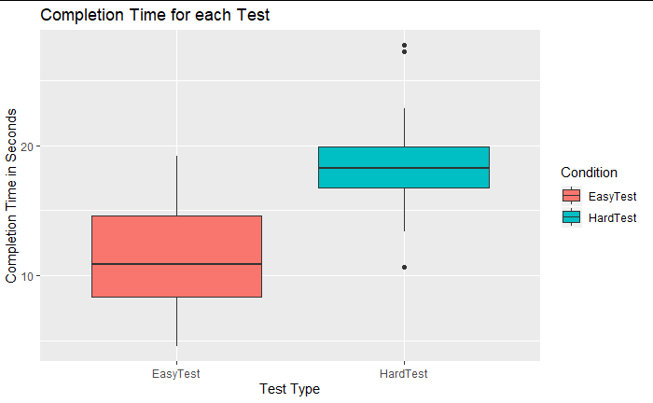

**Figure 3: Completion Time for each Test (Boxplot)**

**Figure 4: Completion Time for each Test (Histogram)**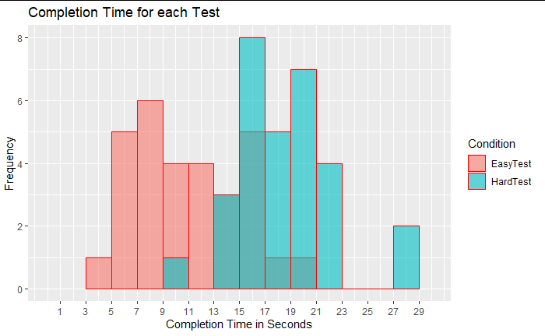

## Inferential Statistics

### Dependent & Independent Variables

To start with our inferencial investigation, first we need to identify the dependent and the independent variables from our allocated dataset. Whereas the type of test (Easy or Hard test) is considered the independent variable, the time of completion of each test is the dependent variable.

### The Hypothesis

Our team’s hypotheses is as follows:

(the notion of E refers to the easy test, H refers to the hard test, and μ refers to the population mean)

**Null Hypothesis: μE ≥ μH** There is no significant difference in the completion time’s mean for both the easy and hard tests.

**Alternative Hypothesis: μE< μH** There is a significant difference in which the completion time’s mean for the easy test is less than the completion time’s mean for the hard test.

Since this hypothesis involves comparing two means that are from the same participants, and the dependent measurement is observed under two different conditions, we will apply the inferential statistical method: **Paired Samples t-Test.**

### Normality Check

#### Q-Q plot

First, we need to check the distribution of the differences between the results of the two tests as it is an assumption before we apply the paired t-test. We can perform the normality check by either a visual inspection or a significance test.

The following chart resembles the Q-Q plot (Quantile-Quantile) that shows the correlation between the sample and the normal distribution. 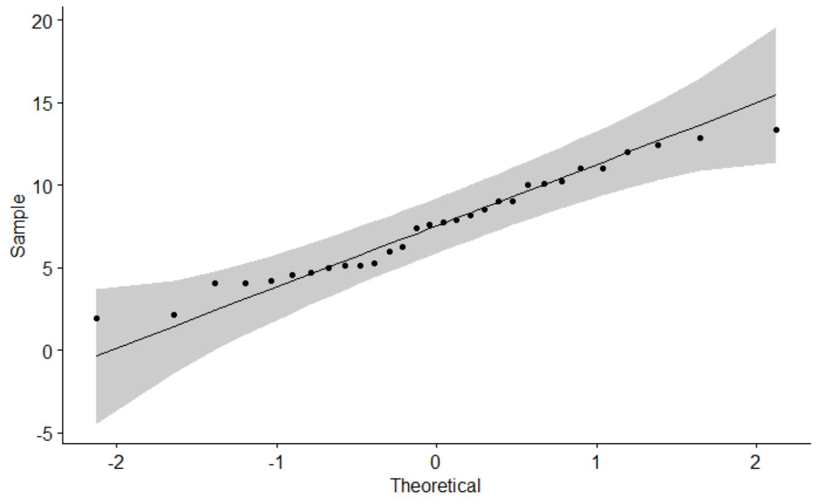

#### Shapiro-Wilk test

The R code below applies the Shapiro-Wilk test to ascertain whether the sample severely deviates from normality or not:

> shapiro.test(stroopdata$Difference)

Shapiro-Wilk normality test

data: stroopdata$Difference

W = 0.96395, p-value = 0.3892

Since the p-value 0.3892 > 0.05, we can assume the normality.

### Statistical Decision

To get the statistical decision using a one-tailed paired-samples t-test, we will use the t.test() function from R.

#### At Confidence level = 90% (α = 0.10):

Paired t-test

data: stroopdata$EasyTest and stroopdata$HardTest

t = -12.951, df = 29, p-value = 6.947e-14

alternative hypothesis: true difference in means is less than 0

90 percent confidence interval:

-Inf -6.786086

sample estimates:

mean of the differences

-7.550667

#### At Confidence level = 95% (α = 0.05):

Paired t-test

data: stroopdata$EasyTest and stroopdata$HardTest

t = -12.951, df = 29, p-value = 6.947e-14

alternative hypothesis: true difference in means is less than 0

95 percent confidence interval:

-Inf -6.560057

sample estimates:

mean of the differences

-7.550667

#### At Confidence level = 99% (α = 0.01):

Paired t-test

data: stroopdata$EasyTest and stroopdata$HardTest

t = -12.951, df = 29, p-value = 6.947e-14

alternative hypothesis: true difference in means is less than 0

99 percent confidence interval:

-Inf -6.115281

sample estimates:

mean of the differences

-7.550667

### Summary: Inferential Statistics

The following table summarizes the statistical decision for each of the aforementioned confidence level:

|  |  |  |  |  |  |
| --- | --- | --- | --- | --- | --- |
| Confidence level | t-static value | critical value accepted range | p-value | Sample mean of the differences | Confidence Interval of the mean differences |
| 99% | -12.951 | [-2.4620 : ∞] | 6.947e-14 | -7.55 | [- ∞ : -6.11] |
| 95% | -12.951 | [-1.6991 : ∞] | 6.947e-14 | -7.55 | [- ∞ : -6.56] |
| 90% | -12.951 | [-1.3114 : ∞] | 6.947e-14 | -7.55 | [- ∞ : -6.78] |

**Table 2: Inferential Statistics Summary**

## Conclusion

Since the t-static value is not in the accepted t-critical value range in all of the selected confidence levels (99% ,95% ,90%) and the p-value is less than 0.001, we reject the null hypothesis and we can conclude that there is a significant difference in the mean completion times between the two tests, and it takes significantly less time to read the colors of congruent words (easy test) than reading the colors of incongruent words (hard test).

Our null hypothesis, which was presuming that there is no significant difference in the completion time’s mean for both the easy and hard tests, is rejected. We’ve clearly seen a trend which relates to our alternative hypothesis on which the times for completing the hard test were longer with all the confidence levels tested.

Diving on the underlying reasons of this results and according to an article in Frontiers in Psychology, the Stroop test is used in both experimental and [clinical psychology](https://www.frontiersin.org/articles/10.3389/fpsyg.2017.00557/full) tests to “assess the ability to inhibit cognitive interference that occurs when processing of a specific stimulus feature impedes the simultaneous processing of a second stimulus attribute.”

This theory proposes that automatic reading doesn't require focused [attention](https://www.verywellmind.com/what-is-attention-2795009). Instead, our brain simply engages in it automatically. However, the brain has to inhibit the faster/stronger word-recognition process in order to allow the color-recognition to win in the final response. This inhibition requires "selective attention" (attentional focus) to inhibit the competing conflicting process, therefore the **reaction time is an indicator of the "attentional process" in the brain.**

Several research papers have been published regarding the question on whether the Stroop test results can yield to clear correlation between individuals with ADHD and low performance on the test. For instance, a research paper called *“Stroop Interference a*nd Attention-Deficit /Hyperactivity Disorder: A Review and Meta-Analysis” published by the API (American Psychological Association) on 2007 confirmed that the Stroop test would be able to assesses the ability to control the interference from alternative response tendencies that compete with the one that is adequate given the context, therefore the Stroop test analysis strongly suggested that also this aspect of behavioral inhibition is consistently disturbed in ADHD.

As a matter of fact, ADHD (Attention Deficit Hyperactivity Disorder) subjects often take much longer resolve the conflicts and make more errors due to the insufficient inhibition in the brain circuitry to suppress the ongoing competing processes. Without entering much into technicalities, the main reason for the impulsivity in ADHD patients is due to the insufficient inhibition exerted by the brain circuitry in the prefrontal cortex, which is mediated by the neurotransmitter dopamine. Pharmacological treatment of ADHD symptoms basically restores the level of dopamine, which results in reducing the impulsivity by increasing the inhibition control in the prefrontal cortex.

On the other hand, other research study such as *“Inefficient cognitive control in adult ADHD: evidence from trial-by-trial Stroop test and cued task switching performance”* published by Behavioral and Brain Functions on 2007 did not conclude the same and encouraged to employ tasks with significantly more trials and direct manipulations of bottom-up mechanisms with larger samples.

**References**

# Brain Imaging Centre, Research Centre for Natural Sciences, Hungarian Academy of Sciences. *“Children With ADHD Show Impairments in Multiple Stages of Information Processing in a Stroop Task: An ERP Study”* . 2015

# Behavioral and Brain Functions. *“Inefficient cognitive control in adult ADHD: evidence from trial-by-trial Stroop test and cued task switching performance”*. 2007

# Salud Mental/Servicio de Psiquiatría, Hospital San Telmo, Palencia, España. “*Usefulness of the Stroop test in attention deficit hyperactivity disorder”.* 2010

# Marieke M. Lansbergen and J. Leon Kenemans. Utrecht University. *“Stroop Interference and Attention-Deficit/Hyperactivity Disorder: A Review and Meta-Analysis”*. 2007